Subject: | Academy General English | Stage: | 1
Assessment Type: | Creating Texts | Weighting: | 25%
Name of Assessment: | Comedic instructional video
Important context:

This assessment is about exploring the visual techniques, tropes, and conventions of instructional videos in order to parody them. In-class we will be focusing on cooking videos, but you are allowed to parody any genre of instructional video. This is useful as a lot of the content we digest is short, video-based content, and this will boost your capacity to critically assess conventions and create high quality digital content.

Key assessment info:

- You will submit a video file for this assignment, via Moodle. Scripts will be accepted for assessment, but will impact the likelihood of success against the performance standards.

Assignment timeline:

Job 1 – Engaging in formative in-class activities and readings

- Exploring instructional videos and identifying genre conventions.
- Exploring parody videos and identifying genre conventions.
- Participating in class discussion and taking notes.

Job 2 – Developing parody script and identifying key filming techniques you want to use

- Decide on whether you will be parodying a famous instructor or creating your own character
- Identify what tropes you will play on, and what kind of humour you will use
- Write a script that includes directors notes on key filming choices
- This needs to be reviewed with the teacher before moving forward

Job 3 – Filming comedic video

- Using feedback from the teacher develop your script into a video.
- This can be recorded on your phone, or if you prefer the school has a range of equipment for hire
through the library

 | Week 1 | Week 2 | Week 3 | Week 4 | Week 5
Job 1
Job 2
Job 3

Assessment Conditions:

- Time limit/word count: Maximum of 5 minutes, (roughly 800 words)

- Please submit draft notes to the class Moodle. Due: end of Fridays lesson, Week 3.

- Final recording to be uploaded to class Moodle. Due: Sunday midnight, Week 5.

Assessment Design Criteria:

The specific features are as follows:

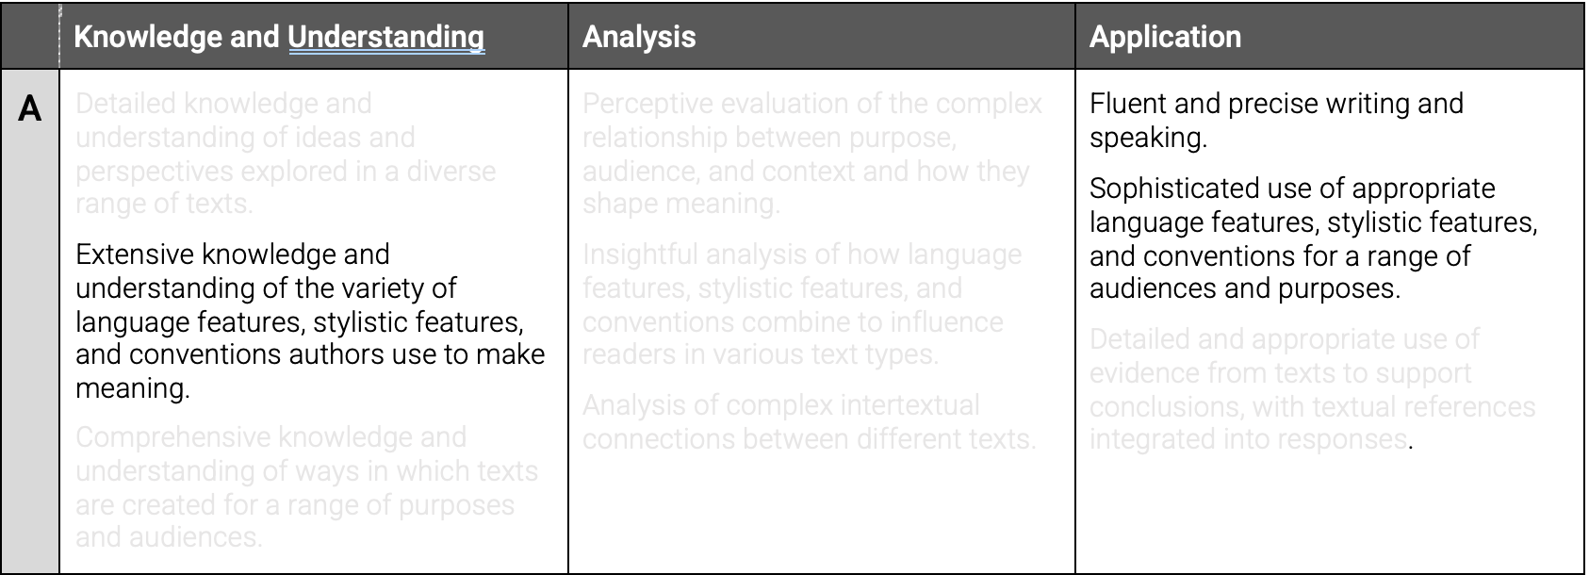

Link to class website with more resources and context:
www.joshuabasford2.wixsite.com/mysite

Performance Standards

